Research Design Document
By Eric Spiteri
Eric Spiteri 5.1 IDM

Table of Contents
Table of Contents 1
Research 2
Main focus of website 2
User Personas 3
Web Accessibility 6

Research

Main focus of website

Property booking websites have all but replaced traditional physical booking agencies nowadays. Instead of having to physically go to a booking agency, consumers simply go online, browse their desired property and information and book.
According to the demographics for websites like booking.com, the target demographics for these websites is mostly young people aged 25-34, with the majority coming from the U.S.A and western Europe and many of them being tech savvy while enjoying travelling as a hobby. Interestingly enough, across all statistics, there is a high percentage of people who bring pets to their accommodation.
Hence, I will design a website with modern aesthetics and design trends in mind as well as include a filter for various options in the view properties page, most importantly the acceptance for pets.
However, I still plan to make it user friendly for older generations by not taking certain icon recognition that younger generations understand for granted. This can be achieved by including both icons and text underneath. Moreover, I will ensure that everything will be readable against a white background by use of contrast.
https://www.dreambigtravelfarblog.com/blog/booking-com-statistics
https://www.igms.com/airbnb-demographics/
(https://www.similarweb.com/website/booking.com/#demographics)

User Personas
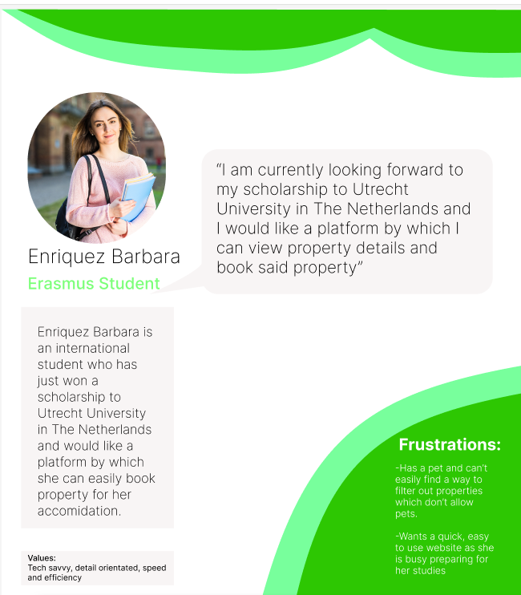

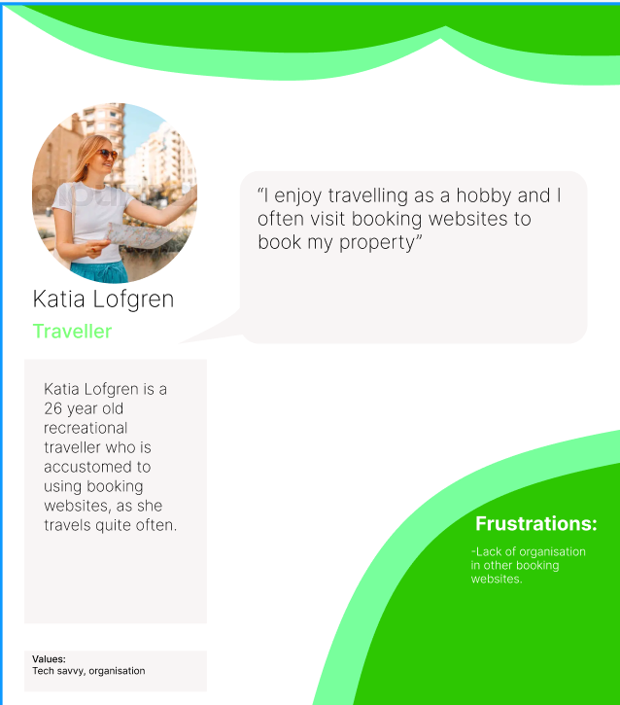

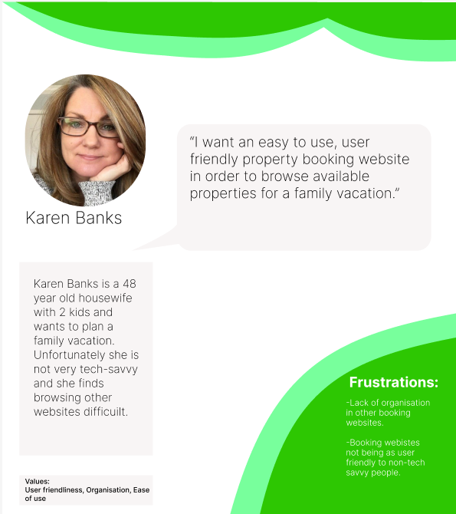

Web Accessibility

Web accessibility facilitates the use of websites for people with disabilities or advanced age. It is important to address this aspect of website design early as it is a crucial part of the design process.
Some examples of making a website accessible to person’s with disabilities or advanced age include:

- Alternate text for images.
This is crucial in the development stage as people with impaired vision often rely on text interpreters to navigate a webpage and having the alternate text be read out loud helps them identify the difference between a clickable link, information text and the actual image.

- High contrast between text and background
People with impaired vision have a hard time reading text like this, therefore it is crucial that there is a contrast between the text and the background, apart from it looking more visually appealing.

- Keyboard navigation
People with impaired motor function often rely on just a keyboard and so implementing a way to navigate the site’s interactive elements with just a keyboard can open up its accessibility to these users.

https://www.w3.org/WAI/tips/designing/
https://www.w3.org/WAI/fundamentals/accessibility-intro/

